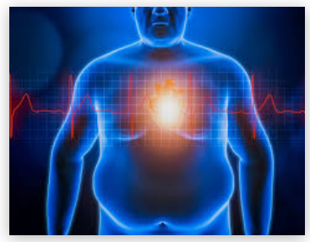Obesity, Obesity and Obesity

**Team Members:**

Amin Ali

Fang Xuan Foo

Narisara Kantanong

Rajesh Nair

**Project Description / Outline**

Upon discussion, we decided to conduct a research on how Obesity rate correlates with the cause in the United States of America. We have chosen to look at Fast Food restaurants availability, the walkability to public transport (Availability), physical activeness, and their age group.

**Research questions to answer**

1. The more accessible the fast-food restaurant the higher the obesity rate?
2. Which gender prefers fast food that leads to obesity?
3. Does the walkable distance to public transport relates to obesity?
4. How many are walking for their day-to-day need? (Location of supermarket, bus stops)
5. The greater number of gyms in a state, the lower the obesity rate
6. The higher rate of physical activeness, the lower the obesity rate
7. What population groups are most at risk to not meet physical exercises?
8. Younger generation that tends to prefer fast food would be more obese
9. Older generation that are more immobile tend to be more obese

**Datasets to be used**

* <https://open.cdc.gov/apis.html>
* <https://cloud.google.com/maps-platform/?_ga=2.80353745.735577293.1618924935-1052635322.1618821265>
* <https://data.world/health/childhood-obesity-in-theus/workspace/file?filename=obesity_child_age.csv>

**Scope**

* Dataset Time to be 2019
* All analysis and data to contain data of all the 50 states in USA, not including Federal District (District of Columbia) and Territories (American Samoa, Guam, Northern Mariana Islands, Puerto Rico, US Virgin Islands)
* Average of Walkable distance - Public transport (Get total for each state)
* Fast food -Include all restaurants in Number of restaurants per state (Heat Map number of Restaurant vs Obesity)
* Top 5 Fast-food restaurants - McDonald's, Starbucks, Chick-fil-A, Taco Bell, Burger King

According to <https://www.eatthis.com/most-popular-fast-food-chains/>

# Instead of pinpoint every individual fast-food restaurant, do a count of the restaurant for each state, use the dot size as the heat map.

* Age group - Children and Teens (Ages 2 - 19 years) Adults - 20 Over
* Physical activity facilities to focus on Gyms, Physical activeness (Meeting CDC requirements -Achieving at least 150 minutes a week of moderate-intensity aerobic physical activity or 75 minutes a week of vigorous-intensity aerobic physical activity and engage in muscle-strengthening activities on 2 or more days a week)

**Rough breakdown of tasks by members**

All team members - Data Wrangling and Data Cleaning, presentation

Amin Ali – Fast Food Questions

Fang Xuan Foo – Physical Activities Question

Narisara Kantanong – Age Group Question

Rajesh Nair – Walkability Questions